Suggestions to help ensure success when using student guide sheets:

Emphasize Ripple Effects is a tool for learning, not entertainment, a game or punishment. Let learners know the program’s purpose is to help youth build strengths/skills, address a problematic behavior, learn more about themselves, solve problems, and understand reasons for problems.

Cover the basics. Make sure learners know where to access the Ripple Effects programs they are using (i.e., guide sheets with links, desktop icons, Clever portal, ClassLink Launchpad).

If program use is required, let them know that you will be checking to see if they have completed the interactive parts of the topic(s)/lessons or any other work that you have assigned. It’s also important they understand that personal/sensitive topics in the program that they view, as well as their journal writing (Brain), is private. You cannot see on the back end what they have done. You will be able to see if the minutes they spent, and if they completed the interactive parts.

Let them know you are there to help them navigate the program and connect them to available if hard or strong feelings come up for them.

See possible prompts for introducing the program and encouraging learner-directed personal problem solving in the implementer’s guides on your Implementation resource page.

The following sample guide sheet templates serve as scaffolds for introducing, assigning, and/or progress monitoring use of Ripple Effects. Customize them to match to your setting.

Included is a Sample Student Survey that can be used to gather student input on site’s programming and use of Ripple Effects.

STUDENT NAME __________________________________________________
Sample Student Guide Sheet

Student ID _______________________________________________

Password prompt________________________________________

Directions
Provide an introduction to program, directions, set expectations, login students
DATE | ASSIGNMENT
 | 1.
 | 2.
 | 3.
 | 4. Personal exploration – choose a topic
 | 5.
 | 6.
 | 7.
 | 8. Personal exploration – choose a topic
 | 9.
 | 10.
 | 11.
 | 12. Personal exploration – choose a topic
Insert instructions here
List topics that you want students to complete or choose from. For “Personal exploration” students choose their own topics from the TOPICS list in the program
Hello, to begin using Ripple Effects, follow login and assignment instructions below:
Sample Student Guide Sheet for Discipline/Intervention Setting

Click on Ripple Effects for Teens icon (hyperlink icon w/your site url or provide directions to access the program in their Clever portal/ClassLink launchpad)

ASSIGNMENT
- Please complete the following topic(s) in the program. Be sure to finish the “Brain (all five parts)” “Got it”, and “Profile” buttons of each assigned topic.

1. (insert either the topic for which the learner was referred, area of concern, or a related skill-building topic.)

2. (insert either the topic for which the learner was referred, area of concern, or a related skill-building topic.)

- When you have completed all the parts of the topic, please let me know.

- Often when students have challenges or get in trouble there is a reason behind it. What do you think might be the reason behind your behavior? See if you can use the program to problem solve it. Click on the “topics” button and use the search bar or scroll through the list to find the topic you are looking. If you need help finding the topic or using the program, I’m here to help.

After using the program, if you would like to talk with someone, please let me know and I can help make that happen. You can also leave a message here:

Sample Exit Reflection Sheet for Intervention/Discipline Setting
The goal is for you to learn something about yourself that will help you be a more successful learner here at (insert name of school). It is time to reflect on the work you have done today and make a plan for improvement.

- Reflecting back on the work you did today, were you able to problem solve the reason behind your behavior?

2. In the future, if you are in a similar situation, what is one thing you can do that will help you to have a more positive outcome?

3. Name ONE person, other than you, who can SUPPORT you in your plan for improvement. How are you related to that person and why did you choose them?

4. If you have any further comments, requests or suggestions please let us know:

Take a moment to think about what you accomplished today. High five/fist bump/pat yourself on the back
for your hard work. Way to take ownership of your learning!
We believe in you and are here for you.

Thank you for being a part of our learning community!

Sample Student Survey to Evaluate your Setting’s Programming

Your opinions matter to our learning community. We would like to hear what you think about the (insert setting/program name) and how it worked for you. Thank you for taking the time to complete this survey!

1. What do you think worked well for you in/during (insert name of your class/setting)? In other words, what do you think we should keep doing?

2. What do you think the (insert name of your class/setting) could do better to help students? In other words, what would you like to see us improve?

3. Do you think Ripple Effects is helpful? YES / NO / MAYBE

Why or why not?

4. How was Ripple Effects helpful?

5. In which ways is Ripple Effects helpful for you? Check all that apply.
______Knowing and understanding yourself
______Controlling myself
______Making decisions
______Predicting consequences
______Improving my relationships
______Communicating
_____ Solving problems
______Other ways
______It was not helpful

7. If you could improve one thing about using Ripple Effects, what would you change?

8. Would you like to have access to Ripple Effects when you have or a challenge or when there is something at school or in life that you want to learn more about? (For example, using it before or after school, at home, during lunch or break…).
YES / NO / MAYBE
Sample Student Guide Sheet

Student Name__________________________
Insert login info & directions
SESSION DATE | TOPICS |  | Brain |  | Profile* | Got It
 | Learn how to login and use the program
 | 2. Your Choice
 | 3.
 | 4.
 | 5. Your Choice
 | 6.
 | 7.
 | 8.
 | 9. Your Choice
 | 10.
 | 11.
 | 12.
 | 13.Your Choice
 | 14.
 | 15.
 | 16.
*Note: not all topics have Profiles

Sample Student Guide Sheet incorporating student self-assessment
Screen for Strengths

STUDENT NAME __________________________________________________

(Insert login info & directions)
DATE | ASSIGNMENT
 | Complete ___(insert)__________________ in Screen for Strengths
 | Introduce program and login instructions
 | 1.
 | 2.
 | 3. Student Choice
 | 4.
 | 5.
 | 6. Student Choice
 | 7.
 | 8.
 | 9.
 | 10. Student Choice
 | 11.
 | 12.
13.
14.Student Choice
 | 15.
 | 16.
 | Complete ________(insert)_____________in Screen for Strengths

Sample Student Guide Sheet for Multi-day Intervention/Discipline setting
NAME __________________________________________________

Insert login info & directions

You know yourself best and are the expert in what you need to be successful! Choose topics from the list below that you think are areas where you can grow. Write the topic names you will complete in the table below.

Day 1 | - (Insert assigned topic/lesson)  - Student choice - choose a topic
Day 2 | 1. (Insert assigned topic/lesson)  2. (Insert topic/lesson for which student was referred/ infraction)
Day 3 | 1.  - Student choice – choose a topic
(Insert a list of topics that you want students to choose from. For help identifying topics, use the Targeted Prevention Manual or Individual Behavior Manual located on the implementation support webpage: https://rippleeffects.com/teachers/)

Sample Student Guide Sheet for Getting Started with Ripple Effects for Kids (Ripple Effects roster, adapt steps 1, 2 and 3 if your site uses Clever/ClassLink)

Hello! To get started, follow these steps:

- Put on your earbuds or headphones and click: Ripple Effects for Kids (hyperlink “Ripple Effects for Kids” text with program URL)
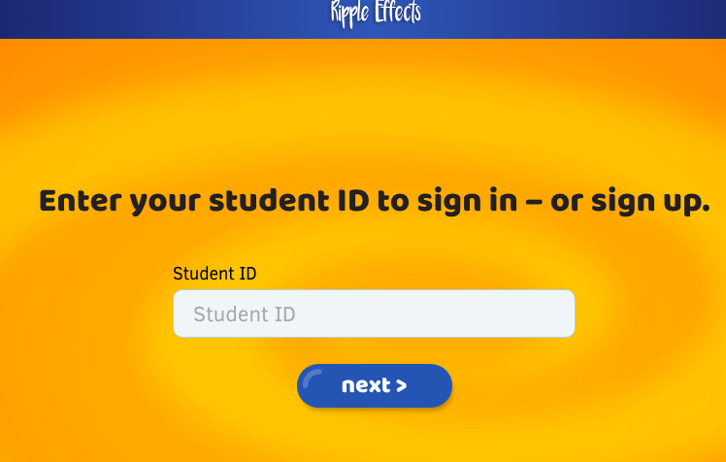
- Where it says “Student ID” enter (insert what students should enter here).
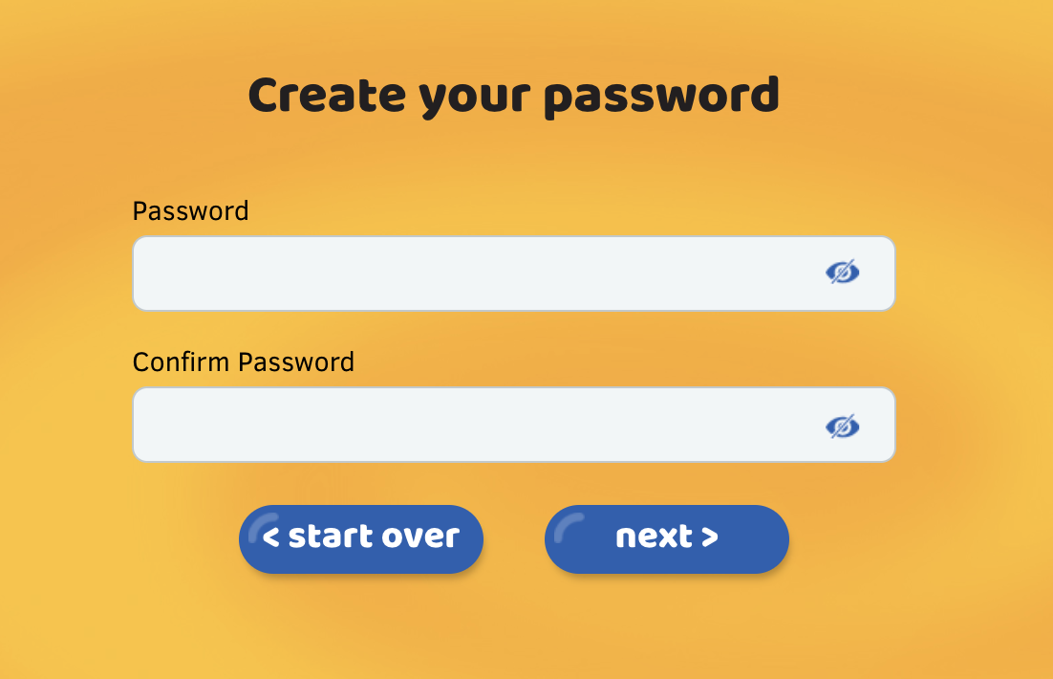
- When it asks you to create a “password, enter (insert what students should enter here). Listen to the directions.

- Then, go to and choose a topic from the list. is found on the top of the page.

- Click on the blue tabs on the side menu to learn about the topic in different ways:

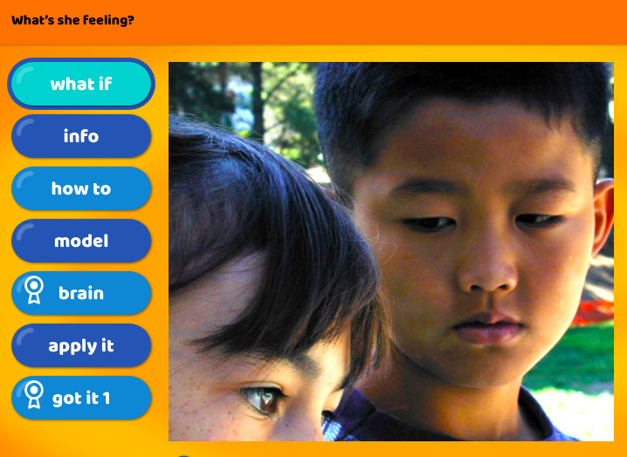

- When you are finished, go back to the and choose another topic.

If you have questions, please contact (insert).

Sample Student Guide Sheet for Getting Started with Ripple Effects for Teens (Ripple Effects roster, adapt steps 1, 2 and 3 if your site uses Clever/ClassLink)

- Hi! This is a program that students say is useful to learn more about themselves and helpful in dealing with hard things. To get started, put on your headphones/earbuds and click on the program that fits your technology:
For laptops & tablets - Ripple Eﬀects for Teens (hyperlink program URL)

For smartphones - Pocket Coach for Teens (hyperlink program URL)

- Where it says, enter your “Student ID,” enter ___________.
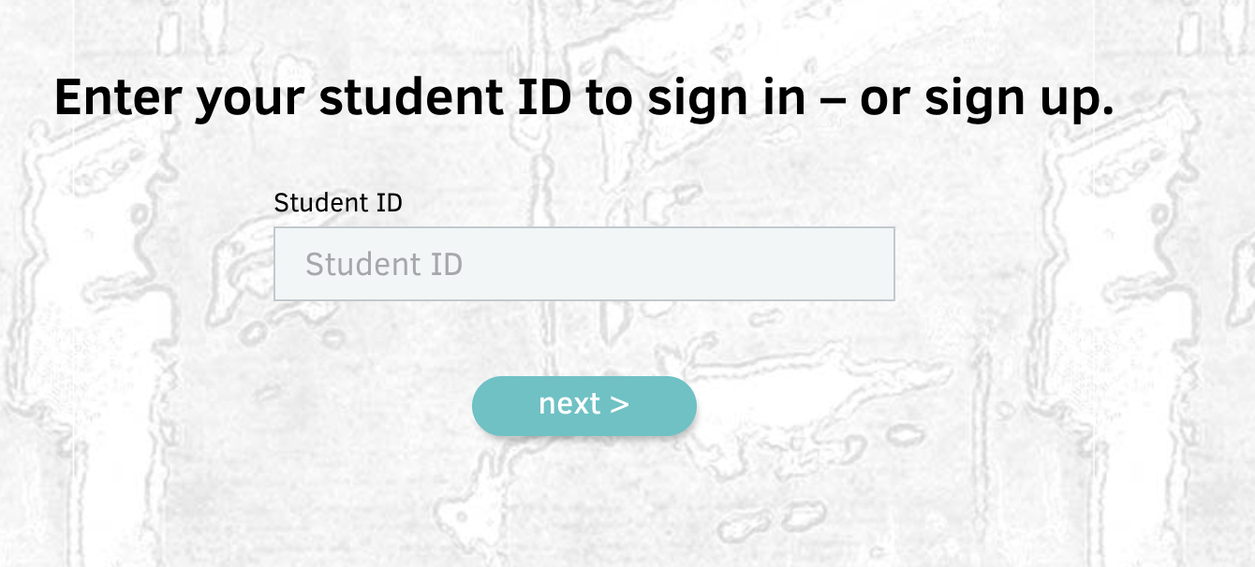
- Where it says, create a “password,” enter/use ____________.
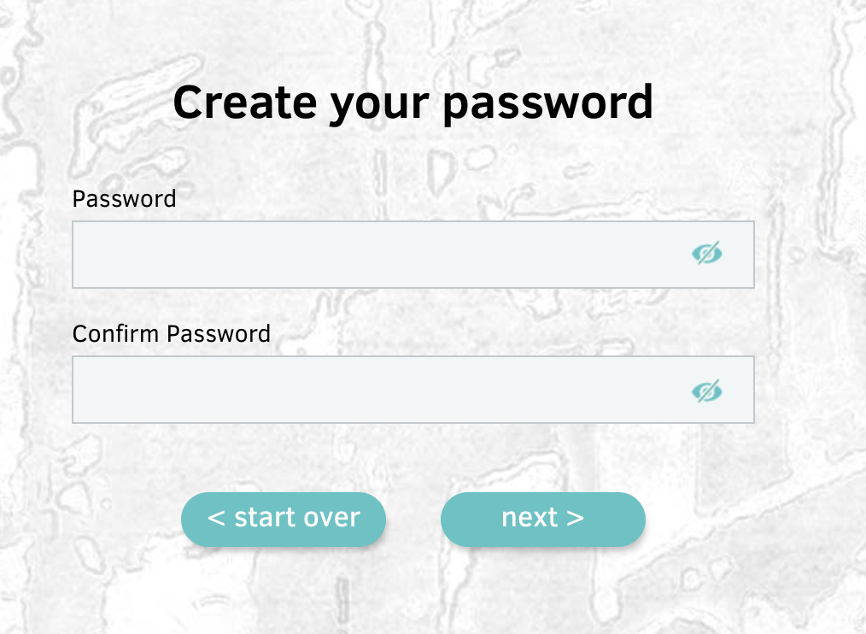
- Click on on the top menu. Choose the (insert name of playlist) playlist and choose a topic.
- Complete the tabs on the side menu.
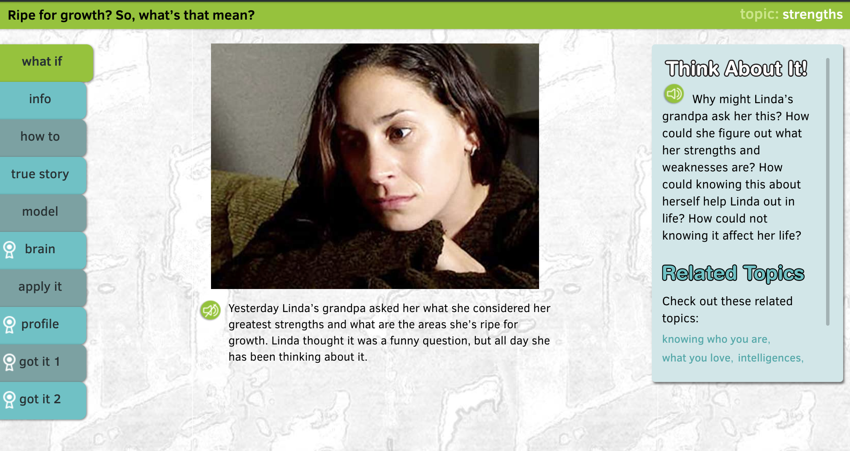
When you have completed all topic, (insert directions).
We are here to support you! If you would like to talk with someone, contact ____________________.

- Hi! This is a program that students say is useful to learn more about themselves and helpful in dealing with hard things. To get started, put on your headphones/earbuds and click on the program that fits your technology:
For laptops & tablets - Ripple Eﬀects for Teens (insert hyperlink)

For smartphones - Pocket Coach for Teens (insert hyperlink)

- Where it says, enter your “Student ID,” enter/use (insert what students should enter here).
Where it says, create a “password,” enter/use (insert what students should enter here).
- Click on the “intro” button to learn how the program works. | 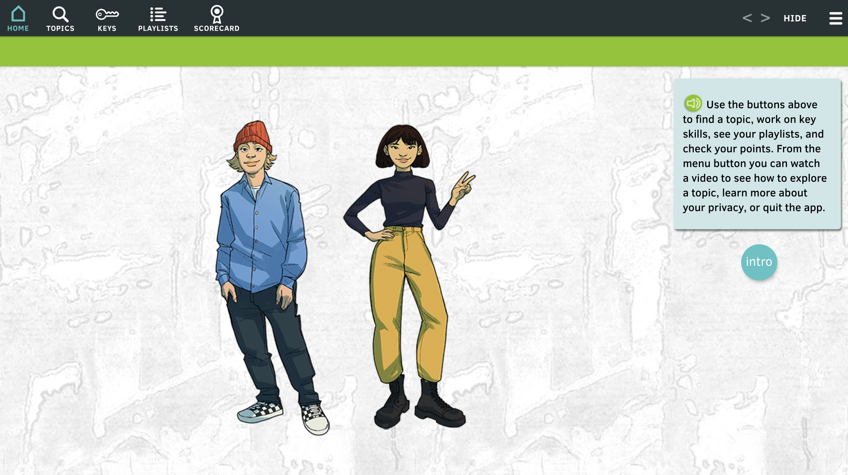
- Click on the TOPICS button in the top menu. Then from the list choose a topic. It could be something that is challenging you; something you are concerned about; or something you just have on your mind. |  | 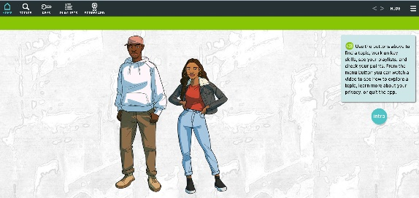
We are here to support you! If you would like to talk with someone, contact ___________________.
Sample Student Guide Sheet for Getting Started with Ripple Effects for Teens (Ripple Effects roster, adapt steps 1, 2 and 3 if your site uses Clever/ClassLink)

(Insert School Name Here) Guide Sheet
To get started, you will need: Ripple Effects Guide Sheet, Laptop/Chromebook/iPad, Earbuds/Headset

- Click on your Ripple Effects Program from your (insert location).

- From the home screen select the intro button for a click-through guide to how to navigate the program.

- Then select, the “How it Works” tutorial to walkthrough how a topic works.

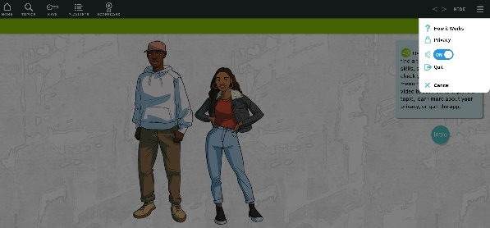

- (Insert assignment. (i.e., “Click on playlist button and…” or “Click on Topics button and choose a….”):

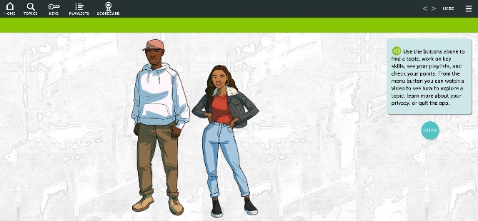
(Insert School Name Here) Student Guide Sheet
To get started, you will need: Ripple Effects Guide Sheet, Laptop/Chromebook/iPad, Earbuds/Headset

- Open your Ripple Effects Program from your Clever Portal or ClassLink Launchpad and click on the icon

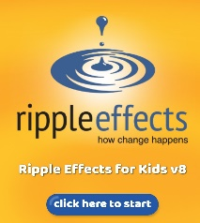
- Select the blue click here to start button

- From the home screen select the intro button for a click-through introduction

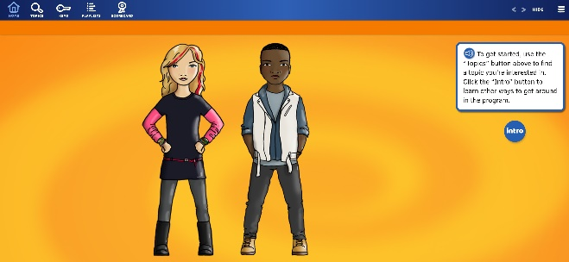

- Select “How it Works” to learn how a lesson works.
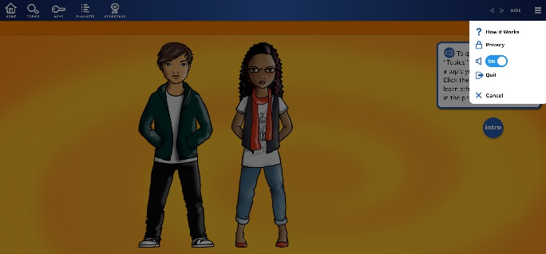

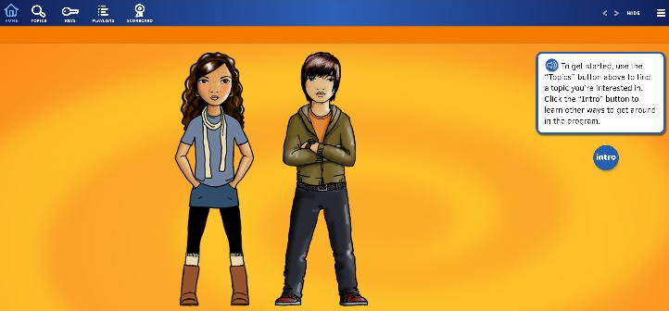
- (Insert assignment. (i.e., “Click on playlist button and…” or “Click on Topics button and choose a….”):

